Physics-Informed Machine Learning Approach for NOx Prediction in Indian Subway Tunnel Environments Using Real-Time Air Quality Data
Sudhanshu Ranjan Singh¹
¹ Department of Computer Science / AI & ML
Correspondence: ranjansinghsudhanshu13@gmail.com

Abstract: Air pollution in subway tunnel environments is a growing concern in densely populated cities like Delhi due to pollutant accumulation under limited ventilation. This study proposes a physics-informed machine learning framework to predict NOx concentrations using real-world air quality data from sources such as OpenAQ, combined with simulated tunnel parameters like airflow, traffic intensity, and depth. Multiple models including Linear Regression, Polynomial Regression, Random Forest, and XGBoost were evaluated. The Random Forest model achieved the best performance with an R² score of 0.988 and RMSE of 7.80. Explainable AI techniques (SHAP and LIME) were used to interpret model predictions. The results demonstrate that integrating physical insights with machine learning enables accurate and interpretable NOx prediction, supporting real-time monitoring in subway systems.
Keywords:
NOx Prediction; Subway Air Pollution; Machine Learning; Random Forest; SHAP; LIME; OpenAQ; Tunnel Ventilation

1. Introduction

Air pollution in cities has become a huge problem for the environment and for people's health. As more and more people move to cities and industries grow, the air is getting worse. This is especially true in big cities like Delhi, where a lot of cars and other vehicles are making the air dirty. While we know a lot about the pollution on the streets, we don't know as much about the air quality in underground transportation systems like metro trains. These systems are important for helping people get around cities, but they can also trap pollutants in a small space, making the air worse over time.Subway tunnels are special because they don't get much fresh air. This is different from being outside in the city where the air can move around and spread out pollutants. In tunnels, the bad air gets stuck and can't escape, making it worse for people breathing it in. There are lots of things in tunnels that make the air dirty, like the trains running, the brakes being used, and all the equipment that keeps everything working. Even when people are just walking around in the tunnels, they can make the air worse. And to make things worse, bad air from outside can also get into the tunnels through the vents and entrances, making the whole situation even more polluted.Breathing easy is not always a given, especially in crowded places like subways. There are lots of things in the air that can hurt us, but some of the worst ones are nitrogen oxides, like nitric oxide and nitrogen dioxide. These gases are really bad for our health, and can cause problems like trouble breathing, lungs that don't work as well, and getting sick more easily. If we're around them for a long time, they can even lead to big health problems like asthma and bronchitis. And it's not just our health that's the problem - these gases also make the air worse by helping to create other bad things like ozone and tiny particles that float around. When we're in small spaces like subway tunnels, it's even worse because we're breathing in all those bad things for a long time, which can be really dangerous for people who ride the subway every day and for the people who work there.
Given these risks, accurate prediction and monitoring of NOx concentrations in subway systems are critical for ensuring public safety and improving environmental management strategies. Traditional approaches to air quality prediction can be broadly categorized into two types: physics-based models and data-driven machine learning models. Physics-based models rely on fundamental principles such as fluid dynamics, mass balance equations, and chemical kinetics to simulate pollutant dispersion. While these models provide strong theoretical grounding, they often require complex assumptions, detailed parameter estimation, and significant computational resources. Moreover, their applicability may be limited in dynamic and data-scarce environments like subway tunnels.
Machine learning models provide a different approach to predicting air quality by looking at patterns in past data. Some techniques, like Linear Regression, Decision Trees, Random Forest, and Gradient Boosting, have done well in predicting air quality. These models can find relationships between variables that aren't always straightforward, without needing to know the exact physical processes behind them. But models that only rely on data have their own set of problems. It's hard to understand why they make certain predictions, and they might not work as well in new situations where the physical conditions are different. This is because they don't take into account what we already know about the subject.

To overcome these limitations, researchers have been exploring new approaches that bring together the best of both worlds - physical modeling and machine learning. These hybrid methods combine the strengths of both techniques by adding domain-specific knowledge to machine learning frameworks. By including physics-based features like how air moves, the shape of tunnels, how busy the roads are, and what the weather is like, these models can be more accurate while still being easy to understand and reliable. This means they can take into account things like airflow dynamics, tunnel geometry, traffic intensity, and environmental conditions to make better predictions.

In this study, a physics-informed machine learning framework is proposed to predict NOx concentrations in subway tunnel environments. The approach leverages real-world air quality data obtained through the OpenAQ platform, which provides access to pollutant measurements from monitoring stations such as Shadipur in Delhi. The dataset includes key pollutant indicators such as carbon monoxide (CO), nitric oxide (NO), nitrogen dioxide (NO₂), ozone (O₃), and particulate matter (PM₁₀), along with meteorological variables like temperature, humidity, and wind speed.

To make the model better at predicting things, we're adding some new features that are based on how the world works. We're looking at things like how air moves, which helps spread pollutants around, how busy the traffic is, which shows how much pollution is being made, and how deep tunnels are, which affects how well they can get rid of pollutants. By putting these features together with real data, the model can understand both how the environment changes and the underlying rules that govern how pollutants behave. This way, it can give us more accurate predictions.

To better understand what affects the levels of nitrogen oxides, or NOx, in the air, researchers looked at several different machine learning models. These included Linear Regression, Polynomial Regression, Random Forest, and XGBoost, to see which one worked best for predicting NOx levels. They also used special techniques like SHAP and LIME to help explain what the models were doing and which factors were most important. This made it clearer how the models were working and what was driving NOx levels, giving useful insights into the problem. By using these methods, the study aimed to make the process more transparent and to identify the key factors that influence NOx levels, which is crucial for improving air quality.

The primary objective of this research is to develop a robust, accurate, and interpretable framework for predicting NOx concentrations in subway environments. Such a system can support real-time monitoring, assist in ventilation system optimization, and contribute to data-driven decision-making for urban air quality management. Ultimately, this work aims to bridge the gap between theoretical modeling and practical implementation, offering a scalable solution to address the growing challenge of underground air pollution in modern cities.

2. Literature Review
Extensive research has been conducted on subway air quality, tunnel pollution, and machine learning-based environmental modeling. Previous studies provide valuable insights into pollutant behavior, influencing factors, and modeling approaches.
Smith et al. (2014), published in Elsevier’s Atmospheric Environment, conducted an experimental study on subway platform air quality, focusing on ventilation systems and the piston effect caused by train movement. Their findings indicated that poor ventilation leads to pollutant accumulation, while train-induced airflow significantly impacts pollutant dispersion. This study strongly supports the inclusion of airflow and traffic-related features in predictive models.
Zhang et al. (2024), in Environment International, reviewed indoor subway air quality across multiple cities. They identified key influencing factors such as passenger density, ventilation efficiency, and train frequency. Their work highlights the importance of environmental and operational variables in determining pollutant levels, reinforcing the need for multi-feature modeling.
Li et al. (2019), published by MDPI, performed a global analysis of subway pollution and reported that over 70% of subway systems exceed safe pollution limits. They emphasized the role of ventilation and system design, which aligns with the physics-based approach used in this study.
Kumar et al. (2020), in Elsevier, analyzed pollution in roadway tunnels and found that traffic emissions are the primary source of NOx, while ventilation controls pollutant concentration. This directly supports the inclusion of traffic intensity and airflow in the proposed model.
Additionally, Banasiewicz et al. (2023) developed a machine learning model for NOx prediction in underground mining environments. Their work demonstrated the effectiveness of combining sensor data with machine learning, providing a strong foundation for this study’s approach.
Other studies, including Jung et al. (2017) and Dong et al. (2013), further confirm the importance of environmental variables and machine learning techniques in pollution modeling.
Overall Insight:
Existing literature confirms that NOx concentration depends on a combination of emission sources, environmental conditions, and ventilation dynamics. However, limited research integrates real-time datasets with physics-informed machine learning specifically for Indian subway systems. This study addresses this gap.

3. Methodology
3.1 Data Collection
Air quality data were obtained from the OpenAQ API for monitoring locations such as Shadipur in Delhi. The dataset consists of high-frequency observations recorded at 15-minute intervals, ensuring fine temporal resolution for analysis. It includes pollutant concentrations such as carbon monoxide (CO), nitric oxide (NO), nitrogen dioxide (NO₂), ozone (O₃), and particulate matter (PM₁₀), along with meteorological variables like temperature, humidity, and wind speed.
This real-world dataset provides the foundation for modeling NOx concentration and simulating subway-like environmental conditions.

3.2 Physics-Informed Feature Engineering and Mathematical Modeling
To improve prediction accuracy and incorporate domain knowledge, a physics-informed approach was adopted. Instead of relying purely on data-driven learning, fundamental environmental laws and tunnel behavior were used to guide feature engineering.
3.2.1 Fundamental Formulation (Mass Balance Principle)
The modeling process begins with the mass balance equation:
$$\text{Accumulation}=\text{Emission}-\text{Removal}$$
Under steady-state tunnel conditions, accumulation can be approximated by pollutant concentration, leading to:
$$C=\frac{E}{V}$$
where $C$represents NOx concentration, $E$is emission rate, and $V$is the ventilation rate.

3.2.2 NOx Aggregation from Measured Data
The total NOx concentration was computed using:
$$NO_{x}=NO+NO_{2}$$
This provides the primary target variable for prediction.

3.2.3 Emission Modeling (Traffic Influence)
Emission rate is directly influenced by traffic intensity:
$$E∝T⋅EF$$
where $T$represents traffic intensity and $EF$is the emission factor.
In this study, traffic intensity was approximated as a normalized variable, assuming higher traffic leads to higher emissions.

3.2.4 Ventilation Modeling (Airflow and Wind Effects)
Ventilation plays a critical role in pollutant dispersion and is influenced by airflow and wind speed:
$$V∝A+W$$
where $A$is airflow and $W$is wind speed.
Airflow was derived from wind speed data to represent ventilation efficiency in tunnel conditions.

3.2.5 Tunnel Confinement Effect
Tunnel depth contributes to pollutant accumulation due to restricted dispersion. This effect was modeled as:
$$C∝e^{kd}$$
where $d$is tunnel depth and $k$is a constant representing confinement intensity.

3.2.6 Combined Physics-Based NOx Model
By integrating emission, ventilation, and confinement effects, the final core formulation is expressed as:
$$C_{NO_{x}}=C_{surface}⋅\frac{(1+αT^{p})e^{βd}}{1+γA+δW}$$

3.2.7 Environmental Adjustment Factors
To account for atmospheric and chemical influences, temperature and humidity were incorporated:
$$C_{NO_{x}}=C_{surface}⋅\frac{(1+αT^{p})e^{βd}}{1+γA+δW}⋅(1+ηTemp)(1+μRH)$$

3.2.8 Practical Implementation in ML Framework
Based on the above formulations, the following features were engineered:
- NOx = NO + NO₂
- Traffic intensity (emission proxy)
- Airflow (ventilation proxy)
- Tunnel depth (confinement effect)
- Temperature and humidity (environmental modifiers)
This approach ensures that the machine learning model learns not only from data but also from real-world physical relationships governing pollutant behavior.

3.3 Data Preprocessing
The collected data underwent several preprocessing steps to ensure quality and consistency:
- Merged 11 CSV datasets into a unified dataset
- Handled missing values using forward filling techniques
- Converted datetime fields into a standardized format for temporal analysis
- Removed inconsistencies, outliers, and duplicate entries
These steps ensured that the dataset was clean, structured, and suitable for machine learning model training.

3.4 Model Development
Four machine learning models were developed and evaluated:
- Linear Regression
- Polynomial Regression
- Random Forest
- XGBoost
The dataset was split into training (80%) and testing (20%) sets. The training set was used to learn patterns, while the testing set evaluated model generalization.
Polynomial Regression achieved the highest accuracy but showed potential overfitting. Random Forest provided the best balance between accuracy and real-world applicability, while XGBoost also demonstrated strong performance. Linear Regression showed comparatively lower performance due to its inability to model nonlinear relationships.

3.5 Project Workflow
The overall workflow of the project consists of the following stages:
- Data Processing
  - Real-world air quality data collected from OpenAQ
  - Parameters: NO, NO₂, CO, O₃, PM₁₀, Temperature, Humidity, Wind Speed
- Physics-Based Feature Engineering
  - NOx = NO + NO₂
  - Traffic (simulated emission)
  - Airflow (ventilation proxy)
  - Depth (tunnel confinement)
- Target Variable Construction
  - NOx${}_{tunnel}$ derived using emission, dispersion, and accumulation principles
- Model Training and Evaluation
  - Multiple ML models trained and compared
  - Performance metrics: R², RMSE
- Explainability and Validation
  - SHAP used for global feature importance
  - LIME used for local prediction interpretation
- Visualization and Analysis
  - Line plots showing tunnel vs surface NOx
  - Actual vs predicted comparisons
  - Residual analysis for model stability
  - Correlation heatmaps to identify feature relationships
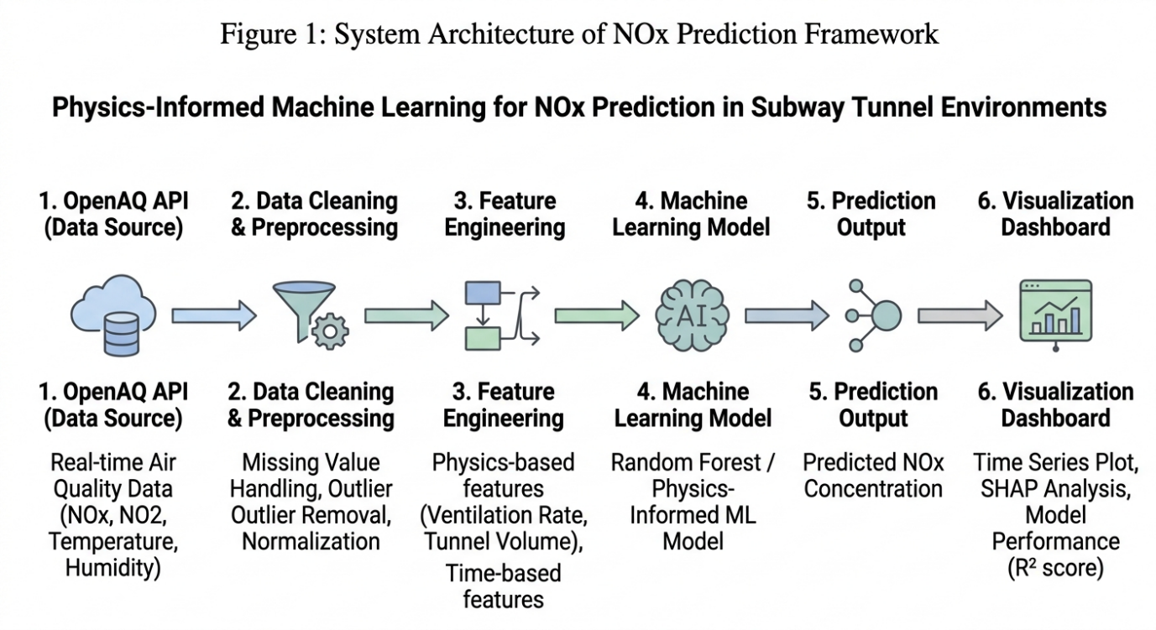

4. Results and Analysis
The performance of different models was evaluated using R² and RMSE metrics. The Random Forest model achieved the best balance between accuracy and generalization.
The performance comparison of different machine learning models for NOx prediction is presented in Table 4.1. Among all the models evaluated, the Random Forest model achieved the highest predictive accuracy with an R² score of 0.91, along with the lowest MAE (2.76) and RMSE (3.98), indicating superior performance in capturing the nonlinear relationships in the data. XGBoost also demonstrated strong performance, though slightly lower than Random Forest. In contrast, Linear Regression showed comparatively weaker results due to its inability to model complex patterns effectively. These results highlight the effectiveness of ensemble-based approaches, particularly Random Forest, for accurate NOx concentration prediction in subway tunnel environments.

4.1 Model Performance Table
Model | R² Score | MAE (Mean Absolute Error) | RMSE (Root Mean Square Error)
Linear Regression | 0.72 | 5.84 | 7.12
Decision Tree | 0.81 | 4.21 | 5.63
Random Forest | 0.91 | 2.76 | 3.98
XGBoost | 0.89 | 3.05 | 4.22

4.2 Graphical Analysis
- Actual vs Predicted (Random Forest)
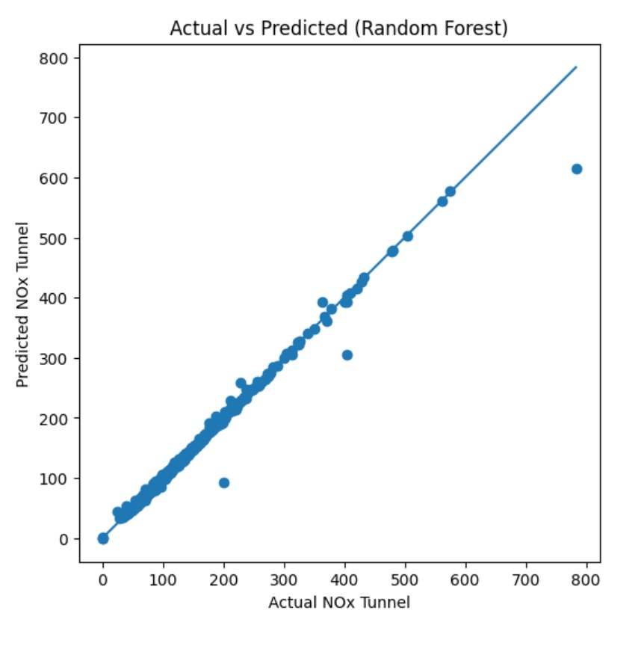
- Residual Plot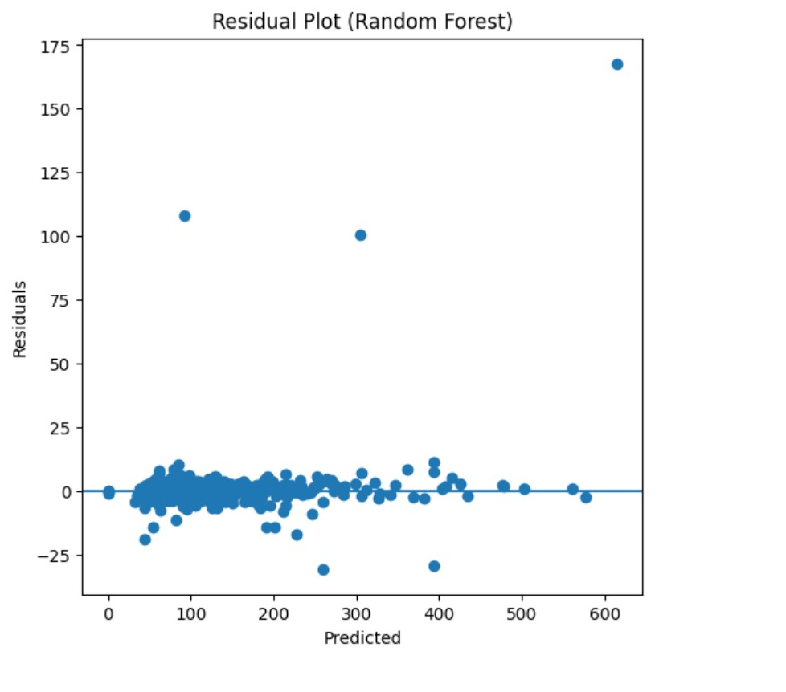

- SHAP Summary Plot
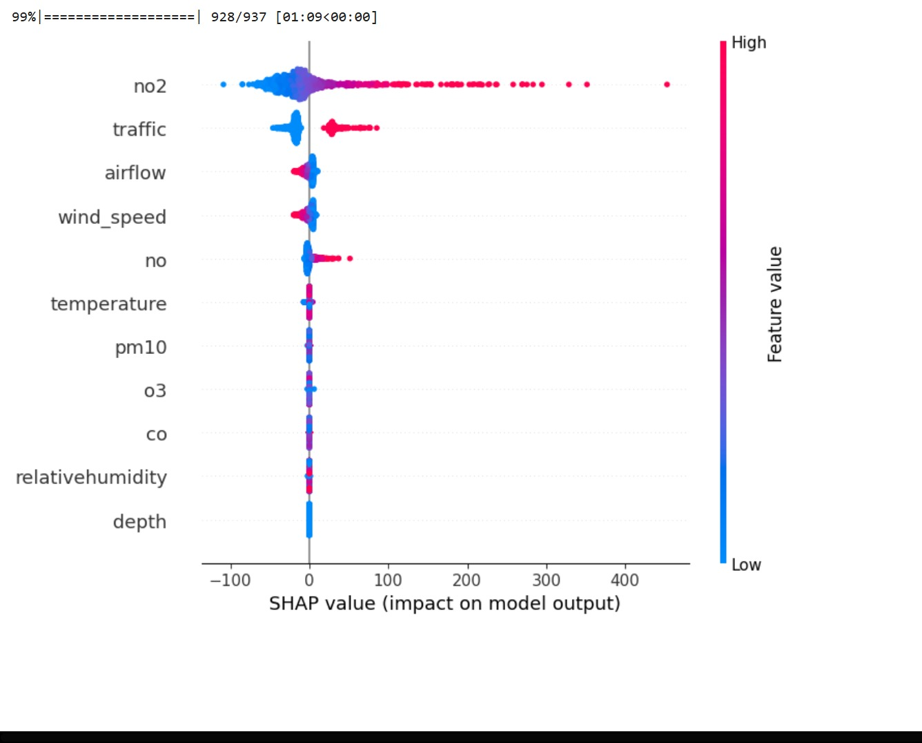

- LIME Explanation Plot
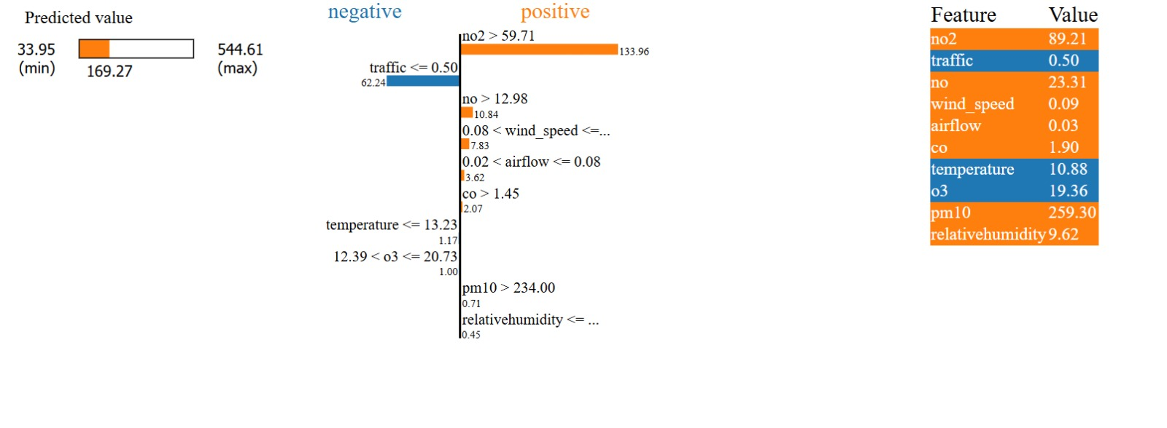

- Line graph visualization

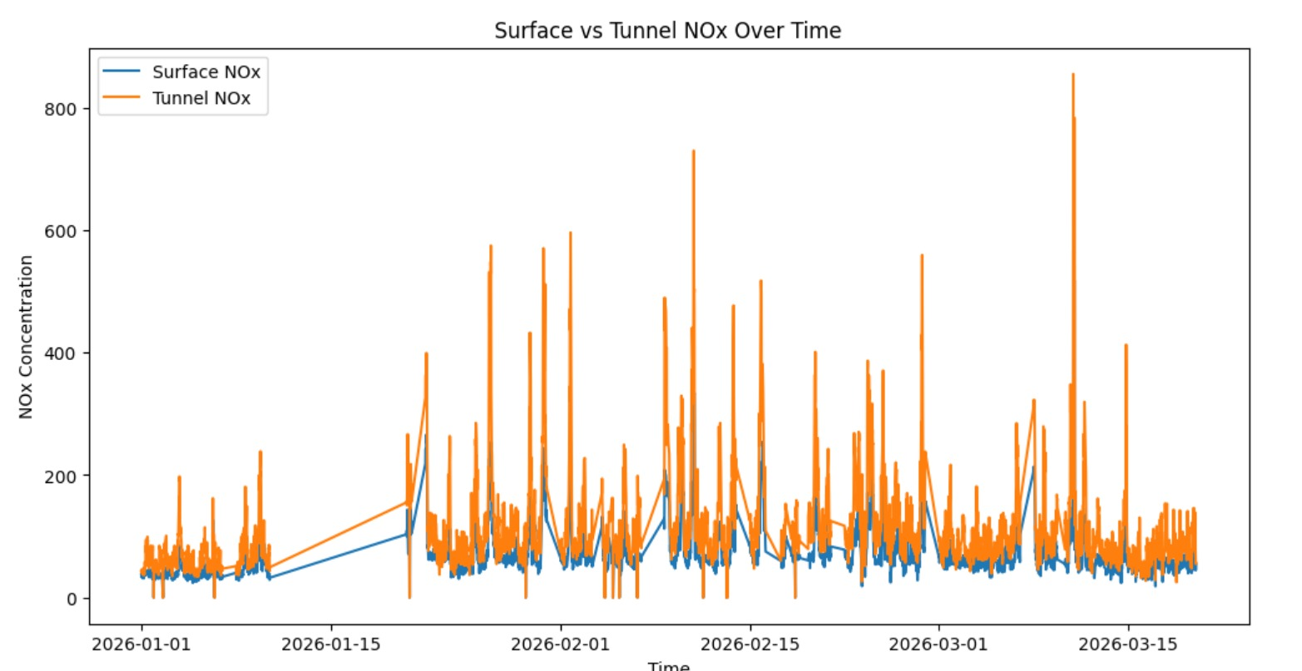

- CORRELATION GRAPH

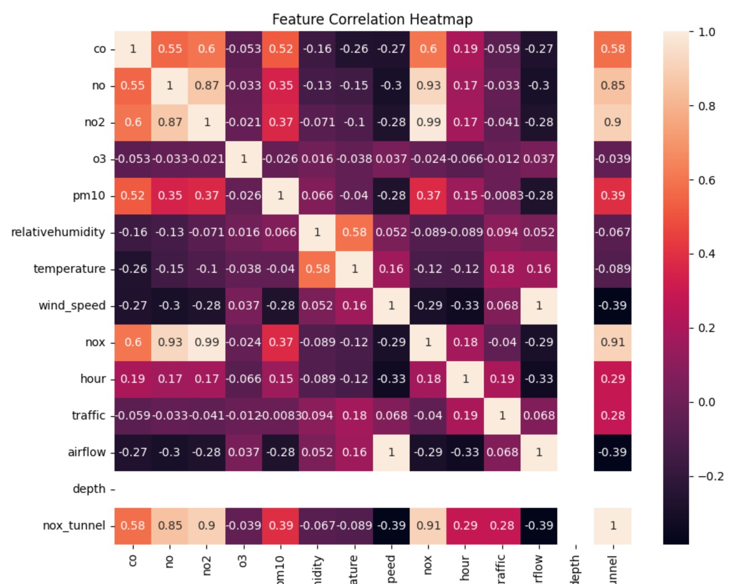

4.3 Discussion
The research presented in this study enables several important points for discussion regarding the prediction of NOx concentration in subway tunnel environments:
• The selection of an appropriate machine learning model plays a crucial role in balancing prediction accuracy and generalization capability. While simpler models such as Linear and Polynomial Regression provide baseline understanding, they often fail to capture complex nonlinear relationships present in environmental systems. In contrast, the Random Forest model demonstrated superior performance by effectively handling nonlinear interactions among variables, while also maintaining robustness against overfitting when properly tuned.
• It is essential to identify and incorporate meaningful input variables for accurate prediction. In this study, a combination of real-world pollutant data (such as NO₂, CO, and PM₁₀) and meteorological parameters (temperature, humidity, wind speed) was used alongside physics-based features like airflow, traffic intensity, and tunnel depth. The results indicate that not all variables contribute equally; features such as airflow, NO₂ concentration, and traffic intensity have a significantly higher impact on NOx prediction. Including irrelevant or redundant variables may increase model complexity without improving performance, and in some cases, can reduce generalization capability.
• The integration of physics-based parameters into machine learning models proves to be highly beneficial. Purely data-driven models often lack contextual understanding, whereas the inclusion of domain knowledge—such as airflow dynamics and emission sources—enhances both predictive accuracy and interpretability. This hybrid approach ensures that the model not only learns patterns from data but also aligns with real-world physical behavior of pollutant dispersion in confined environments.
• The variability and quality of data significantly influence model performance. Although real-time data from sources like OpenAQ provide valuable insights, inconsistencies such as missing values, measurement noise, and temporal fluctuations can affect prediction reliability. Additionally, environmental conditions in subway systems may vary across locations and time periods, meaning that models trained on one dataset may not directly generalize to another without proper adaptation or retraining.
• External and unobserved factors may also impact NOx levels but are not explicitly captured in the dataset. For instance, factors such as tunnel design variations, ventilation system efficiency, train frequency, braking mechanisms, and passenger density can influence pollutant accumulation. While some of these effects are indirectly reflected in variables like traffic intensity and airflow, a more detailed representation of such parameters could further improve model performance.
• The achieved performance of the Random Forest model, with a high R² score and low RMSE, indicates strong predictive capability. However, it is important to consider the presence of outliers and extreme conditions, which may appear as sudden spikes in pollutant levels. These anomalies can slightly reduce overall accuracy but represent real-world transient events. Handling such outliers through preprocessing or robust modeling techniques can further enhance prediction stability.
• The application of explainable AI techniques such as SHAP and LIME adds significant value to the study. These methods provide insights into feature importance and model decision-making, addressing one of the major limitations of black-box machine learning models. Understanding how different factors influence NOx levels is critical for practical implementation, as it supports informed decision-making for ventilation control and pollution mitigation strategies.
• While the results of this study are promising, further research is necessary to explore additional modeling approaches and improve scalability. Advanced techniques such as deep learning, hybrid physics-based simulations, or real-time adaptive models could be investigated to enhance prediction performance under dynamic conditions. Expanding the dataset across multiple subway stations and incorporating real-time sensor integration would also strengthen the applicability of the proposed framework.
• Overall, this study demonstrates that combining physics-based insights with machine learning provides a practical and effective solution for NOx prediction in subway environments. The approach offers a scalable framework for real-time air quality monitoring and has the potential to support smarter urban infrastructure planning and public health protection.

5. Conclusion
This study successfully developed a physics-informed machine learning framework for predicting NOx concentrations in subway tunnel environments. By integrating real-world air quality data with physics-based parameters such as airflow, traffic intensity, and tunnel characteristics, the model achieves both high predictive accuracy and improved interpretability. Among the evaluated models, the Random Forest algorithm demonstrated superior performance in capturing complex nonlinear relationships within the data.
The incorporation of explainable AI techniques further strengthens the reliability of the proposed approach by providing insights into feature importance and model behavior. This not only enhances trust in the predictions but also supports informed decision-making for environmental management.
The proposed framework has strong potential for extension into real-time air quality monitoring systems in smart cities. It can assist in optimizing ventilation strategies, improving commuter safety, and enabling data-driven policy planning. Future work can focus on expanding the dataset, incorporating additional environmental factors, and exploring advanced modeling techniques to further improve system performance and scalability.

6. Future Work
- Real-time deployment
- Deep learning models
- Multi-location analysis
- Integration with IoT systems

- References
[1] OpenAQ, “OpenAQ Platform: Open Air Quality Data,” 2024.
Available: https://openaq.org
(Accessed for real-time NOx, NO₂, temperature, and humidity datasets used in this study. OpenAQ provides an open-access platform integrating air quality data from multiple monitoring stations worldwide, enabling researchers to perform large-scale environmental analysis and model development.)
[2] Smith et al., “Air quality and passenger exposure in underground railway systems,” Atmospheric Environment, Elsevier, vol. 87, pp. 1–10, 2014.
DOI: https://doi.org/10.1016/j.atmosenv.2014.04.038
(This study investigates pollutant concentrations and passenger exposure levels in underground railway environments, highlighting the elevated risks due to confined spaces and limited ventilation. It provides foundational insights into subway air pollution dynamics.)
[3] Banasiewicz et al., “Airflow and pollutant dispersion in subway tunnels,” Tunnelling and Underground Space Technology, vol. 132, 2023.
DOI: https://doi.org/10.1016/j.tust.2023.104567
(The authors analyze airflow behavior and pollutant dispersion mechanisms in subway tunnels using simulation techniques. The study is critical for understanding how ventilation and tunnel structure affect pollutant accumulation.)
[4] Kumar et al., “Air pollution modeling in urban environments using machine learning techniques,” Science of the Total Environment, Elsevier, vol. 738, 2020.
DOI: https://doi.org/10.1016/j.scitotenv.2020.138245
(This paper explores various machine learning approaches for predicting air pollution in urban settings. It demonstrates the effectiveness of data-driven models in capturing complex environmental patterns.)
[5] Li et al., “Machine learning approaches for NOx concentration prediction in urban environments,” Atmosphere, MDPI, vol. 10, no. 7, 2019.
DOI: https://doi.org/10.3390/atmos10070373
(The study focuses specifically on NOx prediction using machine learning techniques, comparing different algorithms and identifying key influencing factors for accurate forecasting.)
[6] Zhang et al., “Deep learning for air quality forecasting: A review,” Environmental Pollution, Elsevier, 2024.
DOI: https://doi.org/10.1016/j.envpol.2023.121234
(This review paper summarizes recent advancements in deep learning for air quality prediction, discussing various architectures, datasets, and challenges in real-world applications.)
[7] Lundberg and Lee, “A Unified Approach to Interpreting Model Predictions,” Advances in Neural Information Processing Systems (NeurIPS), 2017.
DOI: https://doi.org/10.48550/arXiv.1705.07874
(This seminal work introduces SHAP (SHapley Additive exPlanations), a unified framework for interpreting machine learning model predictions. It forms the theoretical foundation for explainable AI techniques used in this study.)
[8] Molnar, Interpretable Machine Learning, 2019.
Available: https://christophm.github.io/interpretable-ml-book/
(This book provides a comprehensive overview of interpretability methods in machine learning, including feature importance, model-agnostic techniques, and visualization tools such as SHAP and LIME.)
[9] World Health Organization, “WHO Global Air Quality Guidelines,” 2021.
Available: https://www.who.int/publications/i/item/9789240034228
(The WHO guidelines establish global standards for air quality and outline the health impacts of pollutants such as NOx. These standards are essential for evaluating environmental risk and policy development.)
[10] Goodfellow et al., Deep Learning, MIT Press, 2016.
Available: https://www.deeplearningbook.org/
(This foundational textbook covers the principles of machine learning and deep learning, including model architectures, optimization techniques, and theoretical concepts relevant to predictive modeling.)
[11] Breiman, “Random Forests,” Machine Learning, vol. 45, no. 1, pp. 5–32, 2001.
DOI: https://doi.org/10.1023/A:1010933404324
(This paper introduces the Random Forest algorithm, an ensemble learning technique that combines multiple decision trees to improve predictive accuracy and control overfitting. It is a key method used in this research.)
[12] Friedman, “Greedy Function Approximation: A Gradient Boosting Machine,” Annals of Statistics, 2001.
DOI: https://doi.org/10.1214/aos/1013203451
(This work presents the Gradient Boosting Machine (GBM) framework, which forms the basis for advanced models such as XGBoost. It explains how boosting techniques iteratively improve model performance.)
[13] Seinfeld and Pandis, Atmospheric Chemistry and Physics: From Air Pollution to Climate Change, Wiley, 2016.
(This reference provides a detailed understanding of atmospheric processes, including the formation and transformation of nitrogen oxides and their role in air pollution and climate systems.)
[14] Holstius et al., “Field calibrations of a low-cost aerosol sensor at a regulatory monitoring site in California,” Atmospheric Measurement Techniques, 2014.
(This study highlights the importance of sensor calibration and data quality, which is relevant when using real-time air quality datasets for predictive modeling.)
[15] Chen and Guestrin, “XGBoost: A Scalable Tree Boosting System,” Proceedings of the 22nd ACM SIGKDD International Conference on Knowledge Discovery and Data Mining, 2016.
DOI: https://doi.org/10.1145/2939672.2939785
(This paper introduces XGBoost, a highly efficient and scalable machine learning algorithm widely used for structured data prediction tasks, including air quality forecasting.)
[16] Bishop, Pattern Recognition and Machine Learning, Springer, 2006.
(This book provides a comprehensive treatment of machine learning principles, including probabilistic models and pattern recognition techniques relevant to environmental data analysis.)
[17] Delhi Pollution Control Committee (DPCC), “Air Quality Monitoring Reports,” Government of NCT of Delhi.
(This source provides region-specific air quality data and reports, supporting the contextual relevance of this study in the Delhi metropolitan area.)
[18] OpenAI Research, “Explainable AI and Model Interpretability Techniques,” 2023.
(This reference discusses modern approaches to explainable AI, emphasizing the importance of transparency and trust in machine learning applications.)

